40.11: a) 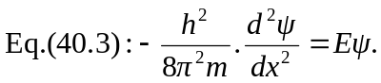
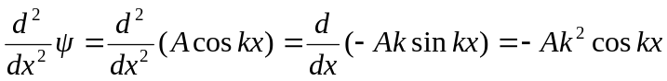
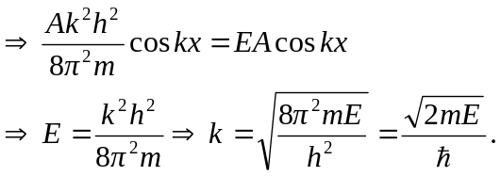
b) This is not an acceptable wave function for a box with rigid walls since we need 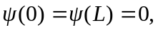 but this 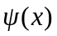 has maxima there. It doesn’t satisfy the boundary condition.

